**Exploring Weather Trends Project**

Submitted by **Saydobid Khusanov**

1. An SQL query to extract the city-level data from the database.

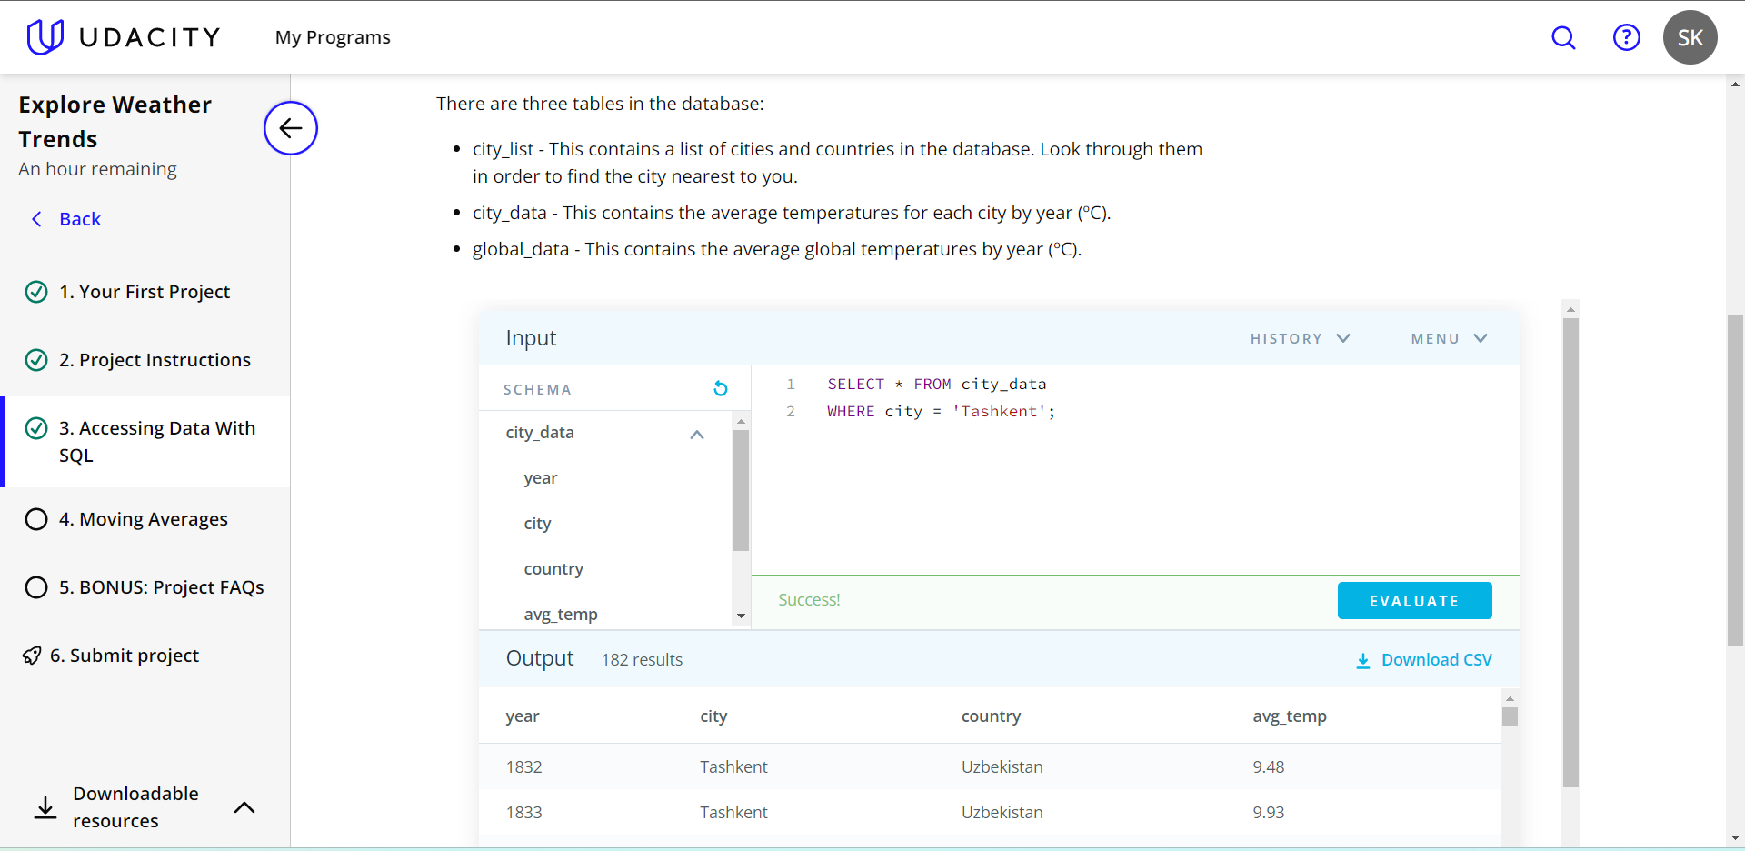

2. An SQL query to extract the global-level data from the database.

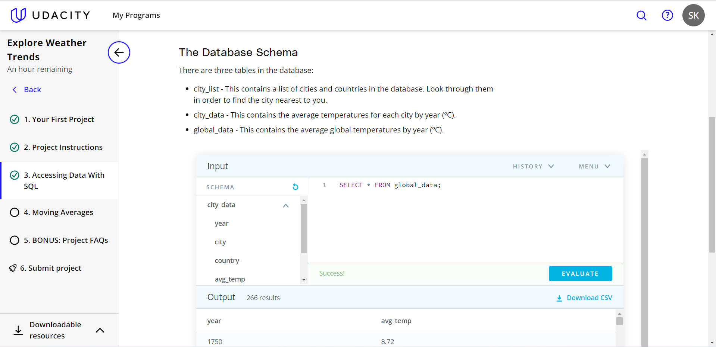

3. After exporting the files I opened them in Excel, and calculated the 5-year moving average temperature of the Tashkent city starting from the available year 1832.

Moreover, I also calculated the same trend in the global range starting from the same year.

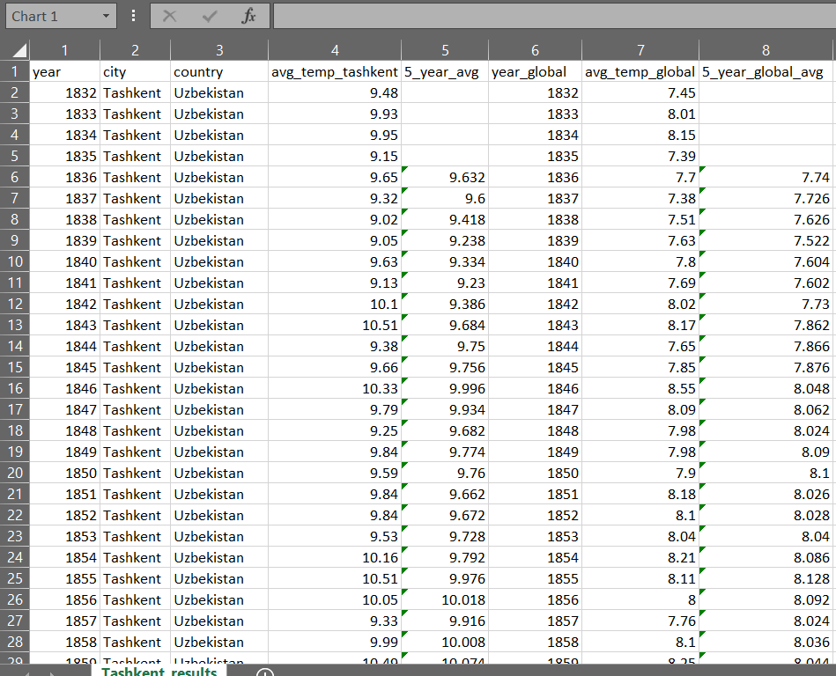

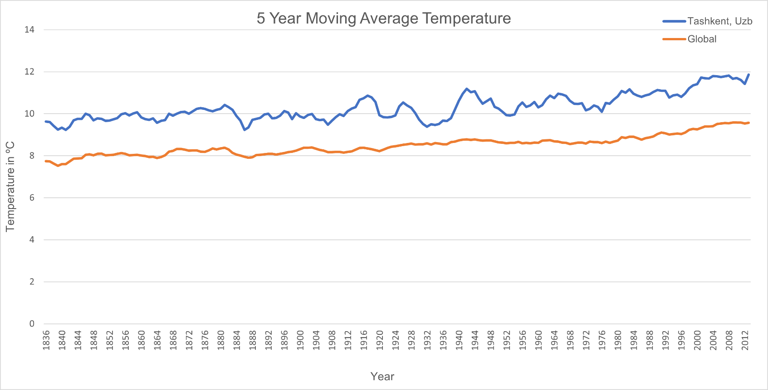4. Finally, I visualized the outcomes using the required line chart in Excel.

5. My observations:

* According to the given data, the 5-year moving average temperature of the Tashkent city has always been higher than the global one for about 2º C during the period of 1836-2012.
* It is noticeable that both trends have gradually risen over the period.
* We can also conclude that the 5-year moving average temperature of the Tashkent city has fluctuated. The temperate had numerous drops between 1880 and 1884, as well as between 1924 and 1932 after a consistent rise along the proceeding years.
* The city-level line indicates the so-called stretched version of the global-level line showing the similar rises and drops between the similar periods.
* The 5-year moving average temperature of the globe and the Tashkent city have risen for about 1.8º C and 2.2º C, respectively, between 1836 and 2012, which clearly indicate the global warming.